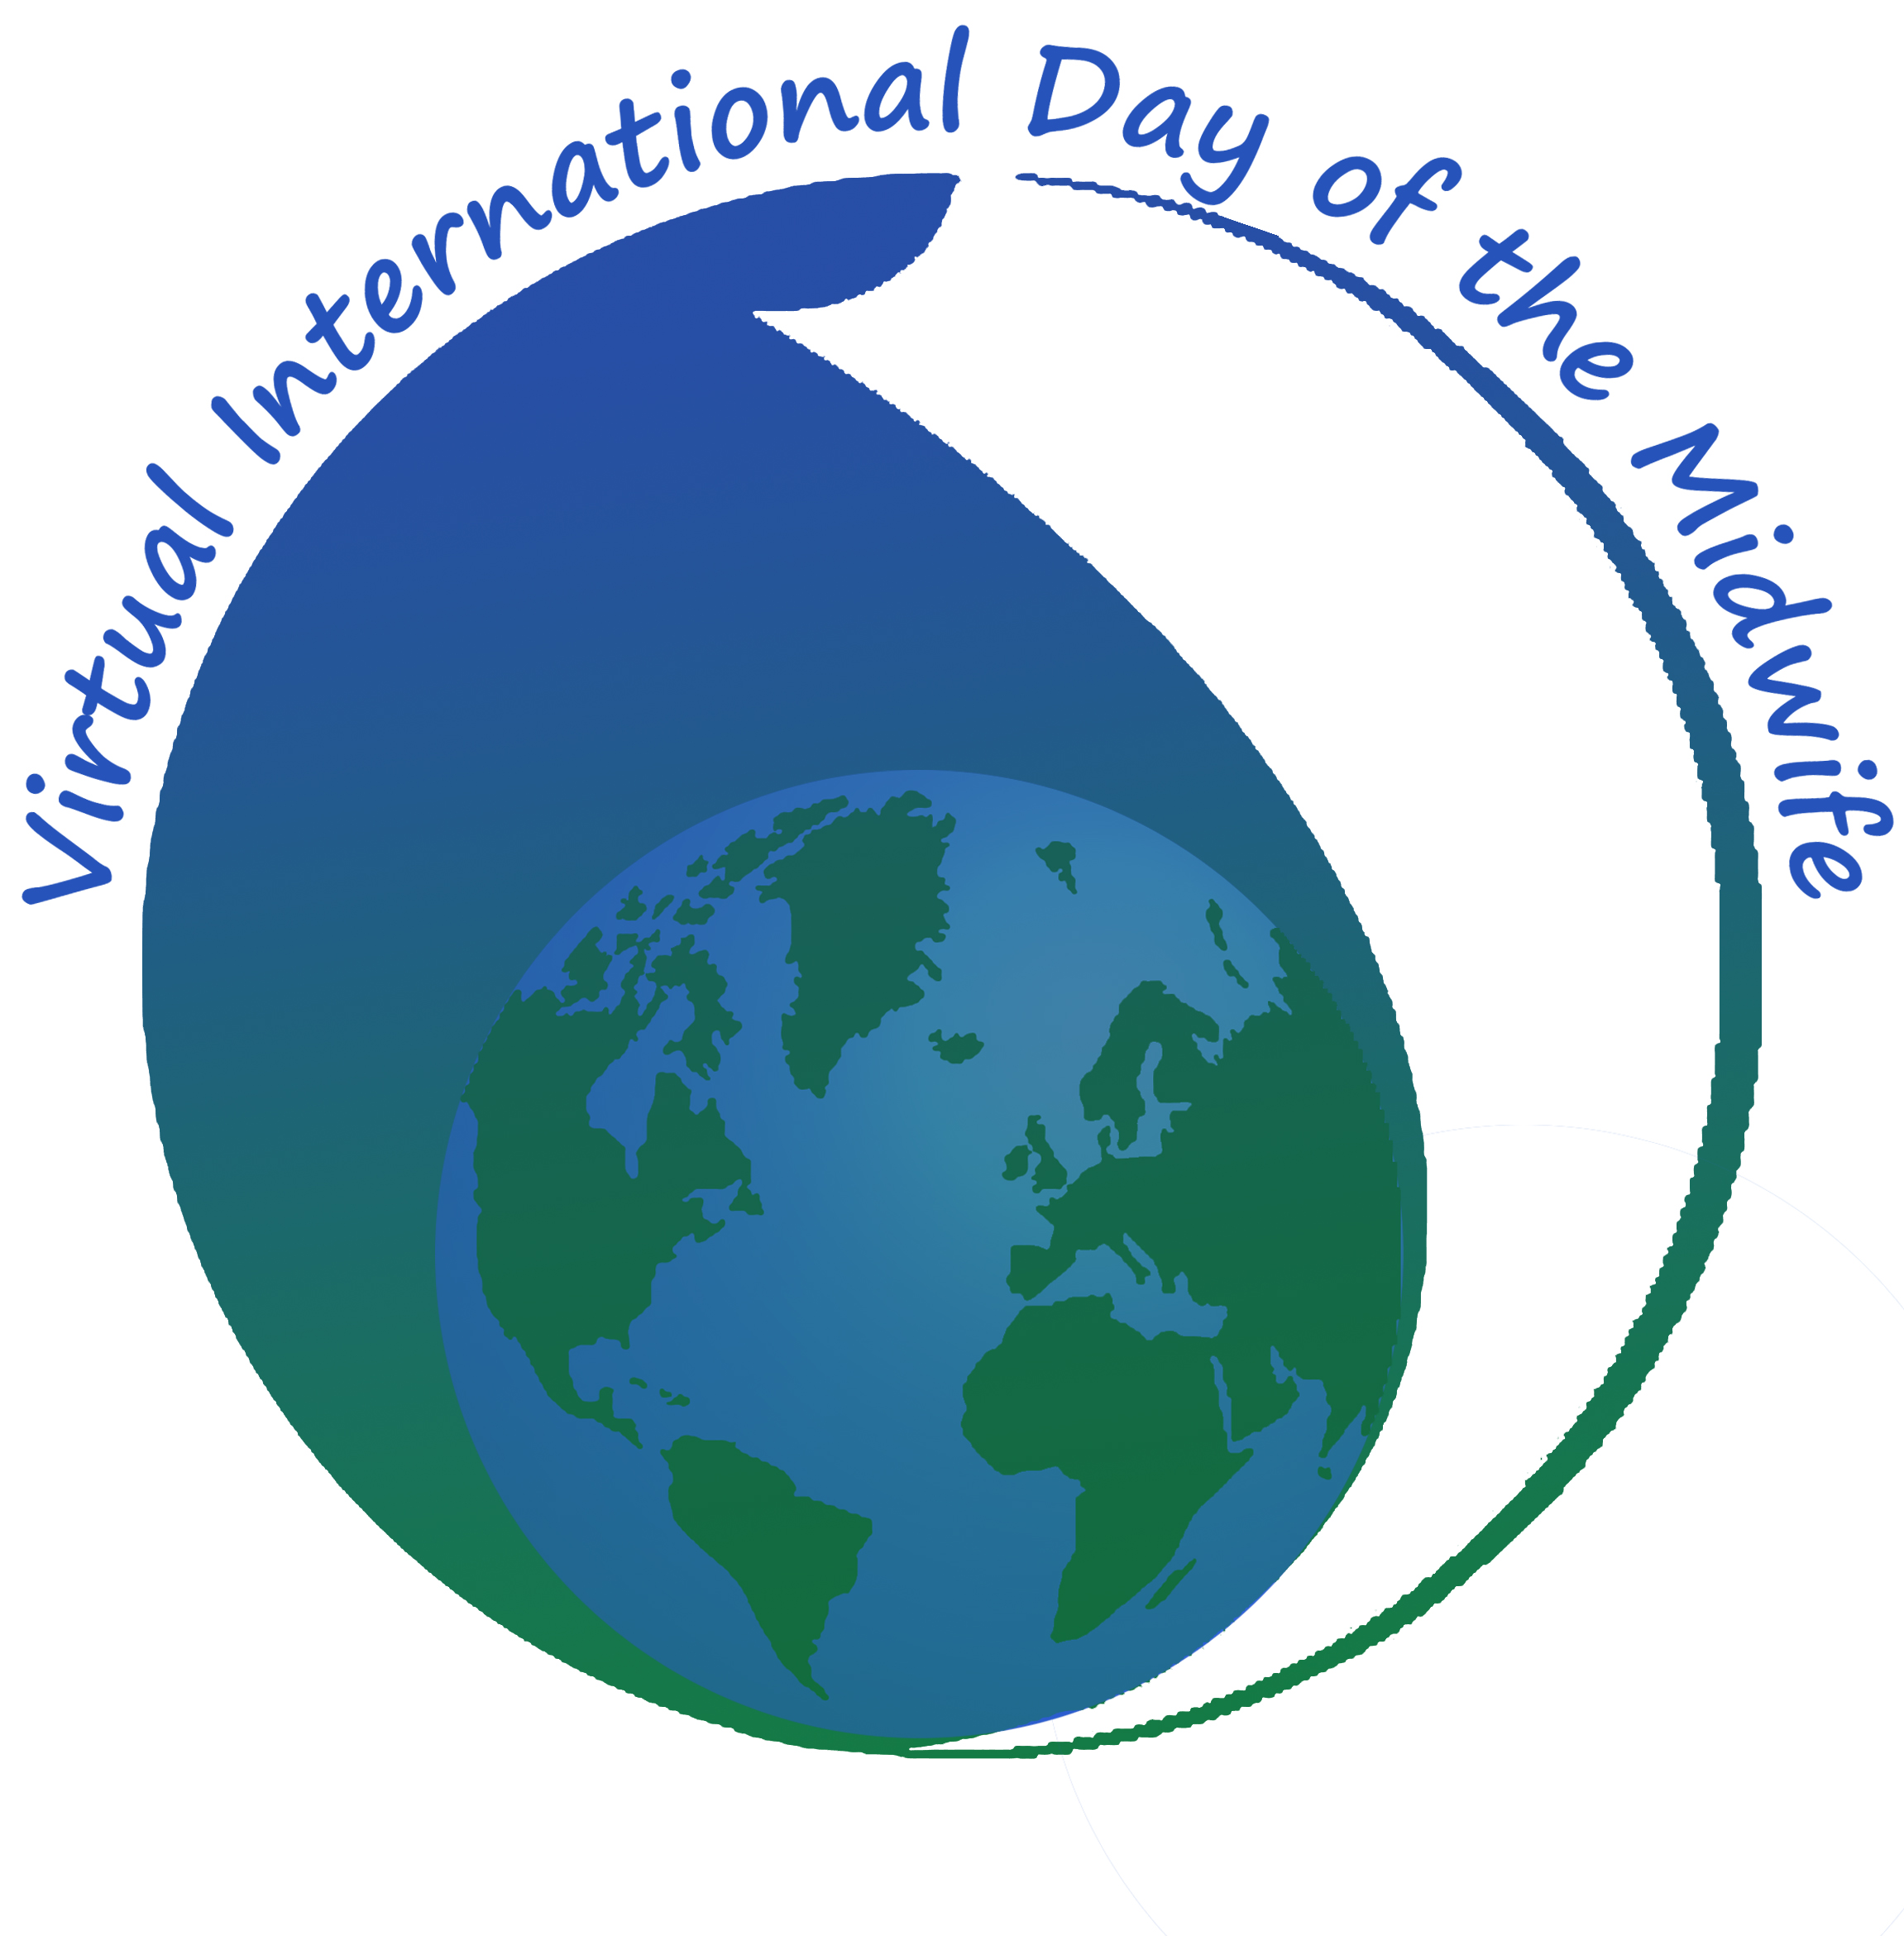

Certificate of Attendance awarded to:-

__________________________________________

For participation in the 11th Annual Virtual International Day of the Midwife

Held on 5th May 2019

Linda Wylie
Conference Convenor

