Every Second Matters for Mothers and Babies – Uterine Balloon Tamponade: ESM-UBT
Partner Organizations:
Mahatma Gandhi Institute of Medical Sciences, BEMPU Health, The African Institute for Health Transformation (AIHT) at Sagam Community Hospital, PATH, One Heart Worldwide, CEFOREP, World Vision, Pathfinder, UNICEF, Jhpiego, the Obstetrics and Gynecology Society (KOGS) of Kenya and elsewhere, KMET, Several Country and County Ministries of Health, Inter-American Development Bank, Peruvian Association of Midwifery and Nursing, Harvard School of Public Health, Boston Consulting Group, Villgro, VentureWell, World Bank, CIDRZ
Status: Fully developed; clinical studies with compelling evidence
Product Cost: $2.85 per UBT device
Contact: Thomas Burke, MD, tfburke@partners.org or Moytrayee Guha, MPH, mguha@partners.org

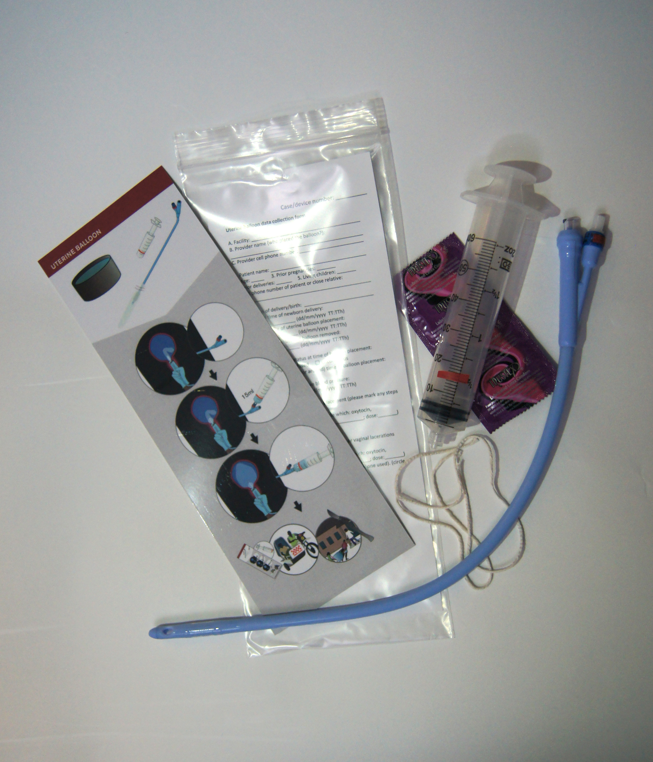
Description: The Every Second Matters for Mothers and Babies Uterine Balloon Tamponade (ESM-UBT) package is designed to address the number one killer of pregnant women in the world. Annually, 2.8 million women on earth lose their lives or become disabled from pregnancy, with postpartum hemorrhage (PPH) the most common cause. The ESM-UBT package includes a 3-hour training curriculum, which incorporates WHO and FIGO standards for PPH management; a PPH wall poster checklist; a job-aid checklist; a trainer’s teaching flipchart; and a learner’s booklet. Also included is the ESM-UBT device which can be used to rapidly halt blood loss and avert hysterectomy in women suffering from uncontrolled PPH.

Existing Evidence: The ESM-UBT package has been introduced by the MGH/Harvard team and partners in South Sudan, Kenya, Sierra Leone, Ghana, Senegal, Tanzania, Zambia, Nepal, Uganda and India. ESM-UBT devices have been successfully placed by various cadres of providers at multiple levels of health facilities and ESM-UBT has been found to be safe at 2- and 6-week follow up.

Hundreds of critically ill women with uncontrolled PPH who have had ESM-UBT devices placed have been closely followed (see references). Among these:
-Women with uncontrolled PPH and early placement of UBT had a 99% survival rate
-Women in class 3 shock at the time of UBT insertion had a 97% survival rate
-Women in class 4 shock at the time of UBT placement had an 86% survival rate
Considerations for Introduction or Use of ESM-UBT: Since 2012, the WHO PPH guidelines have recommended use of the uterine balloon for uncontrolled PPH. The ESM-UBT device is part of the overall ESM-UBT package, which is adapted to fit with country-specific existing competency-based training programs. Health providers may need to be trained on an ongoing basis to maintain competency and confidence.
Field experience suggests that the nomination of regional- and facility-based ESM-UBT “champions” are vital to ensure uptake. The ESM-UBT package has received considerable accolades and endorsements from multiple sources.
The ESM-UBT package is highly effective, ultra-low-cost, easy to use, and ready for global scale in order to end the so very many unnecessary deaths of our world’s mothers.

References:

- Nelson, B. D., et al. "Maternal, Newborn, and Child Survival (MNCS): An innovative training package for building frontline health worker capacity in South Sudan." S Sudan Med J 4.4 (2011): 80-2.
- Nelson, Brett D., et al. "Evaluation of a novel training package among frontline maternal, newborn, and child health workers in South Sudan." International Journal of Gynecology & Obstetrics 119.2 (2012): 130-135.
- Fehling, M., et al. "Development of a community-based maternal, newborn and child emergency training package in South Sudan." Public Health 127.9 (2013): 797-805.
- Nelson, Brett D., et al. "Use of uterine balloon tamponade for control of postpartum hemorrhage by community‐based health providers in South Sudan." International Journal of Gynecology & Obstetrics 122.1 (2013): 27-32.
- Burke, T. F., et al. "A postpartum haemorrhage package with condom uterine balloon tamponade: a prospective multi‐centre case series in Kenya, Sierra Leone, Senegal, and Nepal." BJOG: An International Journal of Obstetrics & Gynecology (2015).
- Natarajan, Abirami, et al. "Provider experiences with uterine balloon tamponade for uncontrolled postpartum hemorrhage in health facilities in Kenya." International Journal of Gynecology & Obstetrics 131.2 (2015): 201-204.
- Pendleton, Anna Alaska, et al. "Emergency hysterectomy for uncontrolled postpartum hemorrhage may be averted through uterine balloon tamponade in Kenya and Senegal." International Journal of Gynecology & Obstetrics 133.1 (2016): 124-124.
- Pendleton, Anna Alaska, et al. "A qualitative assessment of the impact of a uterine balloon tamponade package on decisions regarding the role of emergency hysterectomy in women with uncontrolled postpartum haemorrhage in Kenya and Senegal." BMJ open 6.1 (2016): e010083.
- Natarajan, Abirami, et al. "Use of prophylactic uterotonics during the third stage of labor: a survey of provider practices in community health facilities in Sierra Leone." BMC pregnancy and childbirth 16.1 (2016): 23.
- Natarajan, Abirami, et al. "Provider experience of uterine balloon tamponade for the management of postpartum hemorrhage in Sierra Leone." International Journal of Gynecology & Obstetrics 134.1 (2016): 83-86.
- Natarajan, Abirami, et al. "Provider experiences with improvised uterine balloon tamponade for the management of uncontrolled postpartum hemorrhage in Kenya." International Journal of Gynecology & Obstetrics 135.2 (2016): 210-213.
- Ramanathan A, et al. “Safety of a condom uterine balloon tamponade (ESM-UBT) device for use in uncontrolled postpartum hemorrhage”. Submitted to International Journal of Gynecology & Obstetrics.
- Altawil Z, de Redon E, Dinh H, Eckardt M, Nelson BD, Burke TF. Uterine Balloon Tamponade awareness in United States. Submitted to Journal Midwifery & Women’s Health.
- Herrick T, Abu-Haydar E, Burke TF. “Impact modeling of a low cost uterine balloon tamponade package”. Submitted to International Journal of Gynecology & Obstetrics.
- Burke TF, Nelson BD, Guha M, Eckardt M, Oguttu M, Eckardt M. “Condom uterine balloon for women with uncontrolled postpartum hemorrhage in advanced shock”. Submitted to International Journal of Gynecology & Obstetrics.
- Mvundura, Mercy, et al. "Cost‐effectiveness of condom uterine balloon tamponade to control severe postpartum hemorrhage in Kenya." International Journal of Gynecology & Obstetrics (2017).

Links to UBT videos:

Medical Aid Films UBT Training Video

http://www.medicalaidfilms.org/film/uterine-balloon-tamponade/ (password: ubt2016)

Dr. Olunga's Story
http://www.massgeneral.org/emergencymedicineglobalhealth/news/multimedia.aspx?id=651

Midwives Stories from Africa
http://www.massgeneral.org/emergencymedicineglobalhealth/news/multimedia.aspx?id=652

Uterine Balloon Tamponade: Saving Women's Lives Across Africa
http://www.massgeneral.org/emergencymedicineglobalhealth/news/multimedia.aspx?id=653
UNICEF - UBT Technique video
https://www.youtube.com/watch?v=ULJ1IwdPWaU

