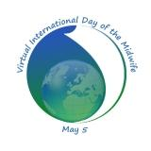

Certificate of Attendance awarded to:-

__________________________________________

For participation in the 8th Annual Virtual International Day of the Midwife

Held on 5th May 2016

Linda Wylie
Conference Convenor

