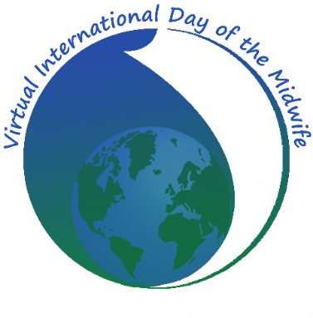
Welcome to the 10th Annual Virtual International Day of the Midwife (VIDM), a 24-hour FREE ONLINE CONFERENCE centred on 5th May 2018 for midwives and anyone interested in childbirth.

The Virtual International Day of the Midwife (VIDM) celebrates the International Day of the Midwife by bringing midwives, students, consumers and all parties interested in childbirth from across the globe together using online electronic media. A variety of live online events are presented every hour for 24 hours on from 4th to 6th May 2018 (depending on your time zone) via web-conferencing facilities. These may include presentations about latest research or practice issues, informal discussions, panel discussions, meetings or story-telling. The start time will be 22:00 4th May, UTC. Follow this link to see the start time in different time zones bit.ly/VIDoM18-start-time

More information is available from the conference website www.vidm.org

The organising committee is now calling for Facilitators to run these hourly sessions. Facilitators should have experience of online meetings or conferences, and be comfortable with online meeting software. Facilitators who are interested in VIDM but who have not worked at the conference before may be invited to shadow an experienced colleague for one or more sessions in 2018, as preparation for running sessions in 2019.

Facilitators must have a reasonable internet connection and they must also have a microphone and headset available. Webcams are not essential as they will not be used during the conference. However, a webcam would be useful during practice sessions as it will help facilitators build their relationships with their speakers/presenters.

Facilitators must be competent working in English. We welcome speakers of other languages, and we might have presentations in Spanish or French this year.

We will be in touch in late March or early April with facilitators to make sure they are all familiar and comfortable with how to run online meeting sessions. Once a facilitator has been paired with her/his presenter(s), s/he will be expected to arrange a practice session with each presenter, to take place in the first two or three weeks in April.

During the conference, every session will be overseen by a Master Facilitator, who is there to support the facilitators. During the practice period in April, there will also be “surgery” style sessions where a Master Facilitator will be present in the virtual practice room to offer support to speakers and facilitators, for example helping them to get used to the environment.

PLEASE COMPLETE THE FOLLOWING TEMPLATE WITH DETAILS OF YOUR AVAILABILITY AND EXPERIENCE

NAME:…………………………………………………………………………………
- Country / time zone you will be working from:
- What local time(s) you will be able to facilitate sessions:
- How many sessions you would be prepared to facilitate
- If you facilitate more than one session
- whether you prefer to have a break between sessions, or
- prefer to facilitate two sessions back-to-back, or
- have no preference
- What online meeting software you have used as an attendee
- What online meeting software you have used as a facilitator, moderator or equivalent
- In what languages in addition to English you can facilitate

Describe your experience in facilitating or moderating online meetings or conferences, your level of expertise with the technologies used and any previous connection with VIDM

Your contact email address ……………………………………….

Please submit your Expression of Interest by 12:00 UTC on Saturday 10th March 2018 ** by email to facilitator@vidm.org

** Follow this link to see the deadline in different time zones:
bit.ly/VIDoM18-Facilitator-EOI

